
Section 21 _ 2005/037806/08

Project Proposal

Out of Africa Dance Academy

2006/2008

FOUNDER / ARTISTIC DANCE DIRECTOR

IVY MEYER

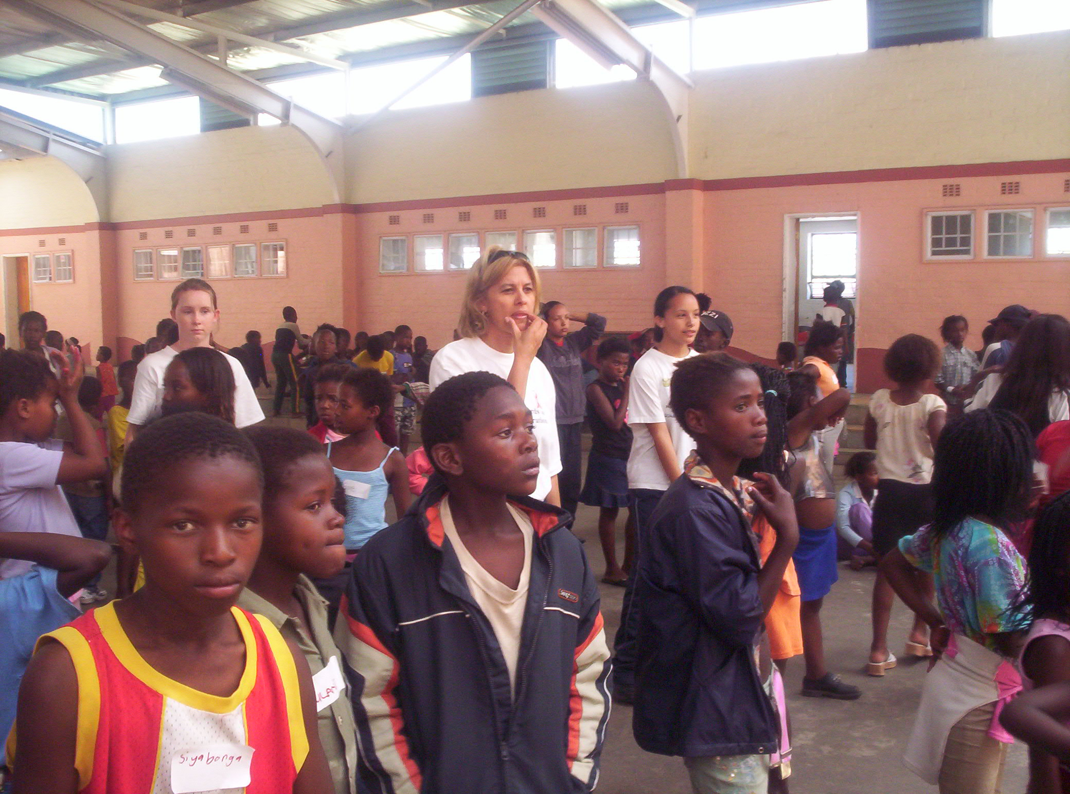

I

Directors: Ivy Meyer – Founder/Artistic Dance /Choreographer: - Stefanie Killian – Artistic Drama
Vanessa Clarence – Admin - Serena Rosslind – Marketing- Robin Bredeveldt: Financial

Part 1
- Details of organisation

Name of organisation | Out of Africa Dance Academy
Street address of organisation | Star of the Sea School Main Road St James
Contact person | Vanessa Clarence
Postal address | 84 Consort Boulevard Retreat 7945
Telephone number | 021 7126056
Fax number | 021 6702427
Cell: | 0836431159
E-mail address | vanessacl@telkom.co.za
Website | www.outofafricadance.co.za
Organisation’s legal status  (E.g. Section 21 Company, NPO) | Section 21 _ 2005/037806/08
2. Person at the organisation that can be contacted to clarify issues
Name of person | Ivy Meyer
Position in organisation | Founder – Artistic Dance Director
Telephone | 021 7882092
Fax | 021 7882594
Cell: | 0836042478
Email | imeyer@mmm.com

3.Financial Controls

Name of Financial Manager: | Robin Bredeveldt
Account name: | Out of Africa Dance Academy
Name of Bank: | Ned Bank
Branch code: | 121121
Account number: | 2211033237
Type of Account  (Current/savings/transmission) | Savings
Name & contact details of auditor: | SAB & T Incorporated Mr Kajie  Willie Van Schoor Ave Bellville  021 9185400

PART 2:

2.1. Management Board
Position |  |  |  | Name |  |  |  |  |  | I.D. number |  |  |  |  |  | Contact number |  |  |  |  |  | Signature
Founder- Artistic Director-dance |  |  |  | Ivy Meyer |  |  |  |  |  | 6210280050088 |  |  |  |  |  | 0836042478
Artistic Director-drama |  |  |  | Stefanie Killian |  |  |  |  |  | 6010180136080 |  |  |  |  |  | 021-7947375
Director-Financial |  |  |  | Robin Bredeveldt |  |  |  |  |  | 6209275233089 |  |  |  |  |  | 0824965926
Director- PR |  |  |  | Vanessa Clarence |  |  |  |  |  | 6008120118085 |  |  |  |  |  | 0836431159
Director-Marketing |  |  |  | Serena Rosslind |  |  |  |  |  | 5602110872080 |  |  |  |  |  | 0844444928
Representivity
Coloured |  |  |  |  |  | African |  |  | White |  |  |  |  |  | Asian |  |  |  |  |  |  |  | Indian
Male |  |  | Female |  |  | Male | Female |  | Male |  |  | Female |  |  | Male |  |  |  | Female |  |  |  | Male |  |  |  | Female |  |  |  |  | male | female | male | female | male | female
1 |  |  | 3 |  |  |  |  |  |  |  |  | 1
 | 2.2 WORKING COMMITTEE
 | Position |  |  |  | Name |  |  |  |  |  | I.D. number |  |  |  |  |  |  | Contact number |  |  |  |  |  | Signature
 | Secretary |  |  |  | Stacy Botes |  |  |  |  |  | 6009090295085 |  |  |  |  |  |  | 0833806805
 | Event Coordinator |  |  |  | Desire Liddle |  |  |  |  |  | 6703260085082 |  |  |  |  |  |  | 0837732732
 | Special Projects |  |  |  | Jeanette Masala |  |  |  |  |  | 5109150644080 |  |  |  |  |  |  | 0832498373
 | Costumes |  |  |  | Yolanda Duminy |  |  |  |  |  | 6707200177081 |  |  |  |  |  |  | 0839687131
 | Back Stage |  |  |  | Tommy Kay |  |  |  |  |  | 5204225073082 |  |  |  |  |  |  | 0845881000
 | Ass- Secretary |  |  |  | Jane Stark |  |  |  |  |  | 6008120118085 |  |  |  |  |  |  | 0824915766
 | Ass -Marketing |  |  |  | Corinne Christians |  |  |  |  |  | 5909010132084 |  |  |  |  |  |  | 0832550025
 | Ass- costumes |  |  |  | Benita Bredeveldt |  |  |  |  |  | 6402230175087 |  |  |  |  |  |  | 0824670392
 | Ass -PR |  |  |  | Diane Viljoen |  |  |  |  |  | 6505030168084 |  |  |  |  |  |  | 0837542319
 | Ass Events coordinator |  |  |  | Joy Richardson |  |  |  |  |  | 6208030287083 |  |  |  |  |  |  | 0829694446
 | REPRESENTIVITY
 | Coloured |  |  |  | African |  |  |  |  |  | White |  |  |  |  |  |  | Asian |  |  |  |  |  |  |  | Indian
 | Male | Female |  |  | Male |  |  | Female |  |  | Male |  |  | Female |  |  |  | Male |  |  | Female |  |  |  |  | Male |  |  | Female
 | 1 | 6 |  |  |  |  |  |  |  |  |  |  | 3

Part 3
PURPOSE OF BUSINESS:
Develop and train youth in performing Arts, Life Skills and Motivational Speakers.

- To use Performing Arts as a medium to address the broader social pathologies and disadvantaged communities.
- Amended service plan to include youth from areas of greatest need
- Out reach youth programmes
- To create a platform of job opportunities for promising dancers of the Academy to become professional dancers or dance teachers.
- To empower beneficiaries to improve their economic and social wellbeing.
- Develop present programmes for youth leadership training
- Partner with organisations that offer projects in line with overall objectives of company.

3.1 GOAL:
- The company’s goal is to have a professional performing art school to provide the youth with skills in the arts.
- The company’s second goal is to organise a Dance TV Program whereby youth from across Africa can showcase their talents and give them opportunities to be in a music video by South African singers, TV Adverts or further their careers in the Arts. (This project in partnership with SABC 1 Jiga Majiga will be introduced to the youth in Cape Town on 17th November 06.)

As a job creation has the Academy identified 10 students who are receiving training to become dance teachers and motivational speakers. This will create a ripple effect as on completion will they be able to invest back into their own communities.

3.2 PARTNERING:

SABC 3 – Vibe’z | TV coverage production | Nkadimeng-0834007004
SABC 2 – SA DEstination | TV coverage projects | Robin - 0835776550

Name of organisation | How they got involved | Contact Number
Glad’s disabled Dance School | Collaborate/ workshops | Gladys -0832705449
Artscape | Production | Marlene- 4109962
Community Newspaper | Media coverage | Fuad- 4884622
South African Dance teachers | Exams/ competitions | Bev - 0832827734
Party with a Purpose | Collaborate | Chad- 0724559452
Dance For All | Collaborate | Phillip - 0829904026
Dept Social services | Holiday projects | Mrs Petersen -4833083
Dance Web JHB | Workshops/collaborate | Craig - 0825399263
Dance Creations | Workshops/collaborate | Andre - 0824675918
Black noise | Collaborate | Emile - 0823958125

3.3 Sustainable Livelihood
A platform of Job creations has been created for the youth in the performing arts to become dance teachers or professional dancers plus motivational speakers.

PART 4:
COMMUNITY PROFILE:
This service offers productive opportunities for the youth during holidays as an alternative to a life of crime, violence and drugs.

The company has identified the following high-risk areas: Masiphumalele Site 5, Lavender Hill, Parkwood, Westlake, and Retreat/Steenberg as the first focus area’s to implement service.

4.1 Partnership between the company and New World foundations community project to offer dance lessons in Lavender hill at Hillwood Primary School. (Due to vandalism of the school is the project on hold?)

4.2 Partnership with the Dept of Social Services – holiday program will the Academy reach the greater areas.

4.3 National and International exposure will give the youth another opportunity of furthering their careers and keep them motivated to reach their goals.

4.4 Partnering with Dept of Social services gave the company an opportunity to identify the lack of recreational activities in the different communities.
In some areas Ballet are offered but majority of the youth showed a greater interest in Hip-hop Street dancing

Part 5:
VISION AND MISSION OF COMPANY:
Out of Africa Dance Academy Strives to expand the horizons of youth within the company plus the youth within the different communities.
- Qualified dance Teacher
- Motivational Speaker
- Professional dancer
.
Through this service leadership, teamwork, self-worth, purpose, discipline, respect and a positive environment will be established and productive opportunities for the youth in the performing arts.

5.1: VALUES
Commitment to community development
Non-racialism
Human rights culture

PART 6:
Problem Statement and solutions
Youth involvement in crime continues to be a challenge in the Western Cape. On average there are 2 223 youth arrests per month. The plight of the youth is exacerbated by substance abuse, poverty, joblessness, unhealthy lifestyles, crime, a low sense of self-worth and a lack of recreational activities. The youth constitutes 46% of the unemployed in the Province; while only three out of every Black job applicants are successful in finding employment. There is a 48% dropout rate in Grades 10-12, while those who have matriculated are exposed to the harsh reality of limited job opportunities.

Ivy Meyer Founder, Artistic dance director and choreographer of Out of Africa Dance Academy who comes from the previously disadvantaged community of Bonteheuwel is a fully qualified dance teacher in both Hip-hop and Modern Jazz via South African Dance teachers association.

Within this context, Out of Africa Dance Academy has been established to create a platform for job creation whereby 10 students from the previously disadvantaged communities, which is part of the Academy can, further their dancing career to become teachers. These students have had opportunities to be motivational speakers at various events and exhibiting their skills and talents in both Dance / Drama have become role models within their own communities. These students had the privilege to be part of the Dept of Social Services and Poverty Alleviation holiday program in December / January whereby disadvantaged youth had an opportunity of a positive fun filled environment and the student teachers of the Academy transferred their skills to the youth as motivation.

6.1 FUTURE PLANS:
- Own performing Arts Studio for all disciplines
- Dance TV Program
.
7. Annual report & Audited statements

As the organisation is within its first year of operation, an annual report and audited financial statement has not been completed.

The company is currently running 3 programs whereby companies have opportunities to choose a project for their investment.

PROJECT BUDGET NO 1.
8. BUDGET 2006 / 2008 - Student Teachers of Academy Training Course

April 06 – March 08
PLANNED EXPENDITURE 2006 - 2008

Student teachers training  R220.00/mth x 12 x 10 students x 2 | R2 640.00 | R52 800.00
Exams Hip-hop level 4 and 5 R200.00/mths 12 x 10 students x 2 | R 2 400.00 | 48 000.00
Exams Modern Jazz Grade 3 and 4 x R260.00/mths 12 x 10 x 2 | R 3 120.00 | 62 400.00
Music Equipment | R 3500.00 | 3 500.00
Petrol pm R800.00 x 12 x 2 | R 800.00 | 19 200.00
CD’s | R 2 500.00 | 2 500.00
 | TOTAL | R 188 400.00

Details to support the Project Plan
  - JOB OPPORTUNITIES FOR 10X STUDENTS OF THE ACADEMY.
  - Invest back into the communities as qualified teachers and the company’s community Projects will continue on a regular basis
  - This job creation programme will be conducted over a three-year period project plan 2 yrs

10: PROJECT BUDGET 2:
Holiday program within the following communities

4 x Areas Identified to continue holiday project: Masiphumalele Site 5, Lavender Hill, Westlake, Parkwood
PLANNED EXPENDITURE 2006 - 2008

School holidays | Dec/Jan | March/April | June/July | Sept/Oct
500 x youth – R80.00/pp | R40 000.00 x 2YRS | R40 000.00 x  2 YRS | R40 000.00 x  2YRS | R40 000.00 x  YRS2
 |  |  | TOTAL: | R320 000.00

Details to support Community project:
10 Student Teachers will be investing their talents to train and develop the skills of the youth in the 4 communities. The project co-ordinator will identify 10 youth of the areas with potential to further their dancing careers with the Academy. Up liftmen of the community has become one of the main focus areas of the Company whereby the selected youth will have an opportunity to train at the current venue with the SA team.

  - COMMUNITY - PROJECT BUDGET: 3
April 06 – March 08
20 Youth of Community
PLANNED EXPENDITURE 2006 - 2008

Hip-hop exams Level 1 & 2 | R200.00/pp x 20 x 2 | R 8 000.00
Costumes for exams | R250.00/pp x 20 x 2 | 10 000.00
Competition - Local | R250.00/pp x 20 x 2 | 10 000.00
Costumes for competition | R600.00/ pp x 20 x 2 | 24 000.00
Food and Pocket money | R500.00/pp x 20 x 2 | 20 000.00
Petrol | R500.00/mth x 12 x 2 | 20 000.00
 | TOTAL | R92 000.00

Details to support Community project 3:
This will give the youth an opportunity to participate in national and International competitions and represent South Africa in Germany.

  - Sustainability of the Project
The youth have an opportunity of improving their dance skills and could become dance teachers or professional dancers and job opportunities are created.

- 2 Constraints / Risks
A lack of funds could result in a potential dropout rate by students and the Academy not fulfilling their vision.

  - . Constitution
A copy of the Constitution is attached

